DAA Practical 12 – Travelling Salesman Problem
Design and Analysis of Algorithms

Aim
To implement the Travelling Salesman Problem using backtracking to find the minimum cost tour.

Travelling Salesman Problem

1. Algorithm
Algorithm: Travelling Salesman Problem (TSP)

Aim:
To find the minimum cost path that visits every city exactly once
and returns to the starting city.

Input:
- Complete weighted graph of N cities (distance/cost matrix)

Output:
- Best path (tour)
- Minimum tour cost

Steps:
1. Start
2. Fix starting city (say A)
3. Mark starting city as visited
4. Call TSP(current_city, visited_count, current_cost)
5. Stop

Procedure TSP(city, count, cost):
1. If count == N then
Add cost of returning to start city
If this total cost is smaller than min_cost then
Update min_cost and save this path
Return
2. For every unvisited city next
3. Mark next as visited
4. Call TSP(next, count + 1, cost + distance[city][next])
5. Mark next as unvisited (backtrack)

Idea:
Try all possible orders of visiting cities.
Keep the route with the smallest total cost.
Because we try all routes, this is a brute-force / backtracking method.

Example (4 cities A B C D):
Distances:
A-B:10, A-C:15, A-D:20
B-C:35, B-D:25
C-D:30

One best route: A -> B -> D -> C -> A
Cost = 10 + 25 + 30 + 15 = 80

Time Complexity: O(N!) (all permutations)
Space Complexity: O(N)

Note:
TSP is an NP-Hard problem. Brute force works only for small N.

2. Program Code (C Language)
File: Code/tsp.c
#include <stdio.h>

#define N 4
#define INF 9999

/*
Travelling Salesman Problem (TSP)
Find minimum cost to visit all cities exactly once
and return to the starting city
Method: try all possible paths (brute force / backtracking)
*/

int graph[N][N] = {
// A B C D
{ 0, 10, 15, 20 }, // A
{10, 0, 35, 25 }, // B
{15, 35, 0, 30 }, // C
{20, 25, 30, 0 } // D
};

char name[] = {'A', 'B', 'C', 'D'};
int visited[N];
int min_cost = INF;

// path stores the current route
int path[N + 1];
int best_path[N + 1];

void tsp(int city, int count, int cost)
{
int next;

// if all cities visited, return to start
if (count == N)
{
if (graph[city][0] != 0)
{
int total = cost + graph[city][0];
if (total < min_cost)
{
min_cost = total;

// save best path
int i;
for (i = 0; i < N; i++)
best_path[i] = path[i];
best_path[N] = 0; // back to A
}
}
return;
}

// try every unvisited city
for (next = 0; next < N; next++)
{
if (visited[next] == 0 && graph[city][next] != 0)
{
visited[next] = 1;
path[count] = next;

tsp(next, count + 1, cost + graph[city][next]);

visited[next] = 0; // backtrack
}
}
}

int main()
{
int i;

for (i = 0; i < N; i++)
visited[i] = 0;

// start from city A (0)
visited[0] = 1;
path[0] = 0;

tsp(0, 1, 0);

printf("Travelling Salesman Problem\n");
printf("---------------------------\n");
printf("Best path: ");
for (i = 0; i <= N; i++)
{
printf("%c", name[best_path[i]]);
if (i < N)
printf(" -> ");
}
printf("\nMinimum cost: %d\n", min_cost);
printf("Time Complexity: O(N!)\n");
printf("Space Complexity: O(N)\n");

return 0;
}

3. Output
Sample program output:
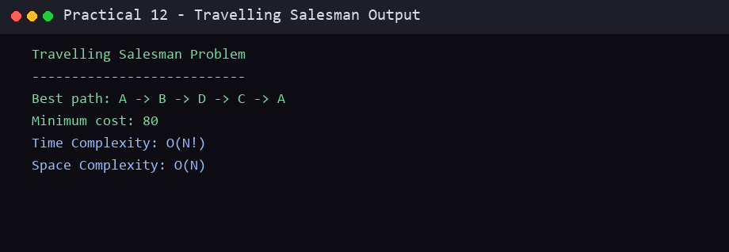

Conclusion
In this practical, the required algorithm was studied and implemented successfully in C. The algorithm, program code and sample output are recorded above. This practical helped in understanding the working and complexity of the technique used.
End of Practical 12

